Assignment 5 (October 3 - 8)

- Compute the directional derivative of the function 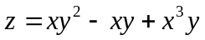 at a point
M (4, -2) in the direction 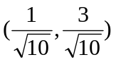.
2. Find the derivative of the function 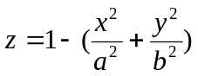 at a point 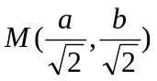 in the direction of the inward normal line at the point M to the curve line defined by 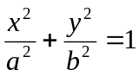.

3. Using the Chain Rule calculate 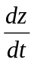 at t=0 if 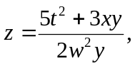 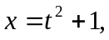 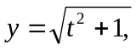 and 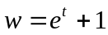.

4. Calculate all partial derivatives of the first order with respect to x and y if 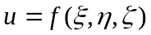, where 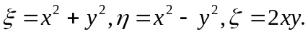

5. Calculate the gradient function and Hesse matrix for the following functions:
a) 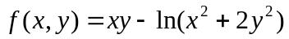; b) 

